UML Class Diagram Relationships, Aggregation, Composition

http://aviadezra.blogspot.com/2009/05/uml-association-aggregation-composition.html
There are five key relationships between classes in a UML class diagram :
Dependency – Association (phụ thuộc)
Aggregation
Composition
Inheritance (exten)
Realization (interface)
These five relationships are depicted in the following diagram:
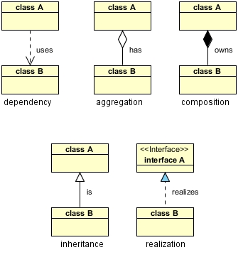
UML Class Relationships
The above relationships are read as follows:
- Dependency : class A uses class B
- Aggregation : class A has a class B
- Composition : class A owns a class B
- Inheritance : class B is a Class A (or class A is extended by class B)
- Realization : class B realizes Class A (or class A is realized by class B)

What I hope to show here is how these relationships would manifest themselves in Java so we can better understand what these relationships mean and how/when to use each one.
Dependency/association is represented when a reference to one class is passed in as a method parameter to another class. For example, an instance of class B is passed in to a method of class A:
public class A {
public void doSomething(B b) { } // A phụ thuộc B
}

Now, if class A stored the reference to class B for later use we would have a different relationship called Aggregation (part). A more common and more obvious example of Aggregation would be via setter injection:

public class A {
private B bb; //object
public void setB(B b) { bb = b; }// B is a part of A ( b là một phần của a)
}
Aggregation is the weaker form of object containment (one object contains other objects). The stronger form is called Composition (). In Composition the containing object is r esponsible for the creation and life cycle of the contained object. Following are a few examples of Composition.
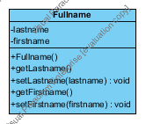

- First, via member initialization:
public class A {
private B b = new B(); // b sinh ra khi a sinh ra
b bắt buộc phải có a
}
- Second, via constructor initialization:
public class A {
private B bb;
public A() {
bb = new B();
}
}// default constructor
- Third, via lazy init:
public class A {
private B _b;
public B getB() {
if (null == _b) {
_b = new B();
}
return _b;
} // getB()

Inheritance is a fairly straightforward relationship to depict in Java:

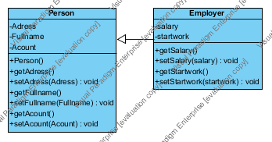

public class A {
...
} // class A

public class B extends A {
....
} // class B
Realization is also straighforward in Java and deals with implementing an interface:
public interface A {
...
} // interface A

public class B implements A {
...
} // class B

